Java ProblemSheet 1

Name: Kaaviya S S Roll. no: 22PT15

1) Write a java program to convert the temperature expressed in Fahrenheit degree into Celsius
degree.

import java.util.Scanner;

public class Fahrenheit_To_Celsius {
public static void main(String args[]) {

Scanner obj = new Scanner(System.in);

System.out.print("Enter temperature in Fahrenheit: ");
float f = obj.nextFloat();

float c = (((f - 32)*5)/9);
System.out.println("celsius:" + c);

}
}

—---------------------------------------------------------------------------------------------------------------------------

2) Write a program that converts distances measured in kilometers to miles. One kilometer is
approximately 0.62 miles.

import java.util.Scanner;

public class Km_To_Miles {
public static void main(String args[]) {

Scanner obj = new Scanner(System.in);

System.out.print("Enter the distance in kilometers: ");
float km = obj.nextFloat();

double m = km * 0.62;
System.out.println("distance in Miles: " + m);
}
}

—---------------------------------------------------------------------------------------------------------------------------

3) Develop a program to calculate Simple Interest & Compound Interest.

import java.util.Scanner;
import java.lang.Math;

public class SI_and_CI {
public static void main(String args[]) {

Scanner obj = new Scanner(System.in);

System.out.print("Enter the principal amount: ");
double p = obj.nextDouble();
System.out.print("Enter the time period (in years): ");
float t = obj.nextFloat();
System.out.print("Enter the rate of interest (in %): ");
float r = obj.nextFloat();

double SI = (p*t*r)/100;
double CI = p*Math.pow((1 + (r/100)),t) - p;

System.out.println("Simple Interest: " + SI);
System.out.println("Compound Interest: " + CI);
}
}

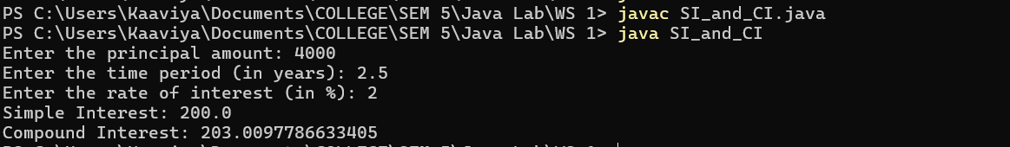

—---------------------------------------------------------------------------------------------------------------------------

4) Write a program to calculate the volume and surface area of a sphere from its radius, given as input.

import java.util.Scanner;
import java.lang.Math;

public class SurfaceArea_Volume {
public static void main(String args[]) {

Scanner obj = new Scanner(System.in);

System.out.print ("Enter the radius: ");
float r = obj.nextFloat();

double surface_area = 4*Math.PI*r*r;
double volume = (4*Math.PI*r*r*r)/3;

System.out.println ("Surface area: " + surface_area);
System.out.println ("Volume: " + volume);
}
}

—---------------------------------------------------------------------------------------------------------------------------

5) Write a program that calculates the cost per square inch of a circular pizza, given its diameter
and price.

import java.util.Scanner;
import java.lang.Math;

public class PizzaCost {
public static void main(String args[]) {

Scanner obj = new Scanner(System.in);

System.out.print ("Enter the Diameter of the pizza: ");
float d = obj.nextFloat();
System.out.print ("Enter the cost of the pizza: ");
float cost = obj.nextFloat();

float r = d/2;
double cost_per_sq = (Math.PI*r*r)/cost;

System.out.println ("Cost per square inch of a circular pizza: " + cost_per_sq);
}
}

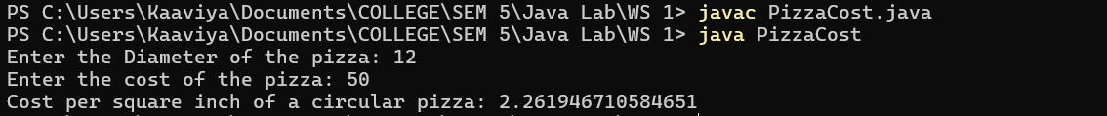

—---------------------------------------------------------------------------------------------------------------------------

6) Write a program that determines the distance to a lightning strike based on the time elapsed
between the flash and the sound of thunder. The speed of sound is approximately 1100 ft/sec
and 1 mile is 5280 ft.

import java.util.Scanner;
import java.lang.Math;

public class LightningStrike_distance {
public static void main(String args[]) {

Scanner obj = new Scanner(System.in);

System.out.print ("Enter the time Elapsed (sec): ");
float t = obj.nextFloat();

// distance to a lightning strike = (speed of sound * time elapsed)/2
int speed = 1100;
float dist = (speed * t)/2;
float dist_mile = dist/5280;

System.out.println ("Distance to lightning (in miles): " + dist_mile);

}
}

—---------------------------------------------------------------------------------------------------------------------------

7) The distance between two cities (in km.) is given as an input. Write the program to convert and print this distance in miles and feet.
Sample Calculation:
Enter the distance between two cities: 50 km.
The distance between the two cities is 50 km or 31.07miles or 164042 foot.
Hint: 1 km is 0.621371mile and 3280.84 foot.

import java.util.Scanner;
import java.lang.Math;

public class City_distance {
public static void main (String args[]) {

Scanner obj = new Scanner(System.in);

System.out.print ("Enter the distance between two cities (in Km): ");
float dist = obj.nextFloat();

double d_mile = dist * 0.621371;
double d_foot = dist * 3280.84;

System.out.println ("The distance between the two cities is " + dist + "Km or " + d_mile + " miles or " + d_foot + " foot.");

}
}

—---------------------------------------------------------------------------------------------------------------------------

8) Two points in a plane are specified using the coordinates (x1, y1) and (x2, y2). Write a program that calculates the slope of a line through two (non-vertical) points entered by the user.

import java.util.Scanner;
import java.lang.Math;

public class Slope {
public static void main (String args[]) {

Scanner obj = new Scanner(System.in);

System.out.println ("Enter the points (x1,y1) & (x2,y2): ");

System.out.print ("Enter x1: ");
int x1 = obj.nextInt();
System.out.print ("Enter y1: ");
int y1 = obj.nextInt();
System.out.print ("Enter x2: ");
int x2 = obj.nextInt();
System.out.print ("Enter y2: ");
int y2 = obj.nextInt();

float m = (y2 - y1)/(x2 - x1);
System.out.println ("slope: " + m);

}
}

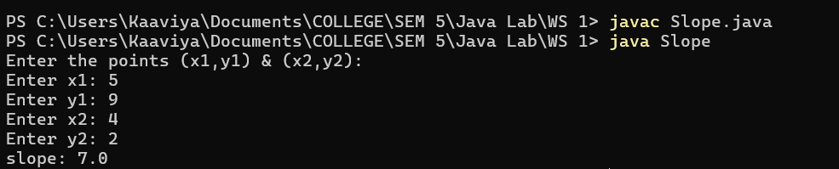
—---------------------------------------------------------------------------------------------------------------------------

9) Write a program that determines the molecular weight of a hydrocarbon based on the number
of hydrogen, carbon, and oxygen atoms.

import java.util.Scanner;
import java.lang.Math;

public class MolecularWeight {
public static void main(String args[]) {

Scanner obj = new Scanner(System.in);

System.out.println("In a hydrocarbon: ");
System.out.print("Enter no. of hydrogens: ");
int h = obj.nextInt();
System.out.print("Enter no. of carbons: ");
int c = obj.nextInt();
System.out.print("Enter no. of oxygens: ");
int o = obj.nextInt();

double wt = h*1.0079 + c*12.011 + o*15.9994;
System.out.println("Molecular weight: " + wt);

}
}

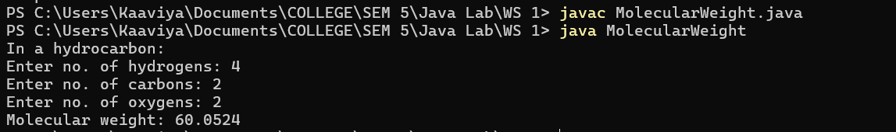

—---------------------------------------------------------------------------------------------------------------------------

10) Write a program that accepts two points (see previous problem) and determines the distance between them.

import java.util.Scanner;
import java.lang.Math;

public class Distance_points {
public static void main (String args[]) {

Scanner obj = new Scanner(System.in);

System.out.println ("Enter the points (x1,y1) & (x2,y2): ");

System.out.print ("Enter x1: ");
int x1 = obj.nextInt();
System.out.print ("Enter y1: ");
int y1 = obj.nextInt();
System.out.print ("Enter x2: ");
int x2 = obj.nextInt();
System.out.print ("Enter y2: ");
int y2 = obj.nextInt();

double x = Math.pow((x2 - x1),2);
double y = Math.pow((y2 - y1),2);
double dist = Math.sqrt(x + y);

System.out.println ("distance: " + dist);

}
}

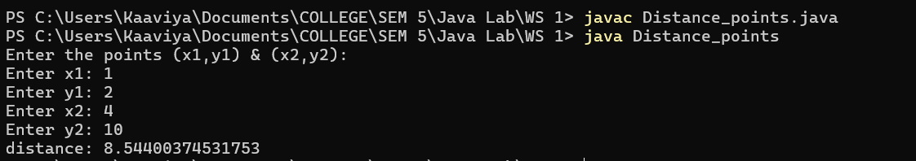

—---------------------------------------------------------------------------------------------------------------------------

11) The Gregorian epact is the number of days between January 1st and the previous new moon. This value is used to figure out the date of Easter. It is calculated by these formulas (using int arithmetic):
C = year/100
epact = (8 + (C/4) – C + (8C + 13) / 25) + 11(year % 19)) % 30

import java.util.Scanner;
import java.lang.Math;

public class GregorianEpact {
public static void main (String args[]) {

Scanner obj = new Scanner(System.in);

System.out.print ("Enter the year: ");
int yr = obj.nextInt();

float C = yr/100;
float epact = ((8 + (C/4) - C + (8*C + 13)/25) + 11*(yr%19)) % 30;

System.out.println ("Gregorian epact: " + epact);

}
}

—---------------------------------------------------------------------------------------------------------------------------

12) Five Bikers Compete in a race such that they drive at a constant speed which may or may not be the same as the other. To qualify the race, the speed of a racer must be more than the average speed of all 5 racers. Take as input the speed of each racer and print back the speed of
qualifying racers

import java.util.Scanner;
import java.lang.Math;

public class QualifyingSpeed {
public static void main (String args[]) {

Scanner obj = new Scanner(System.in);

System.out.println("Enter the speed of 5 racers: ");
float s1 = obj.nextFloat();
float s2 = obj.nextFloat();
float s3 = obj.nextFloat();
float s4 = obj.nextFloat();
float s5 = obj.nextFloat();

float avg_speed = (s1 + s2 + s3 + s4 + s5)/5;
System.out.println("The speed of qualifying racers should be greater than " + avg_speed);

}
}

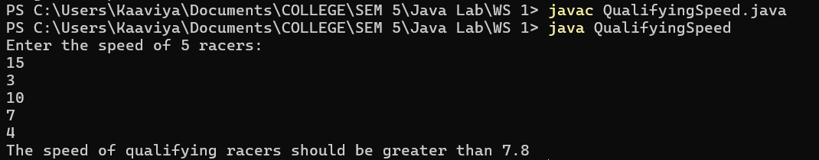

—---------------------------------------------------------------------------------------------------------------------------

13) Meadowdale Dairy Farm sells organic brown eggs to local customers. It charges $3.25 for a
dozen eggs, or 45 cents for individual eggs that are not part of a dozen. Write a program that
prompts a user for the number of eggs in the order and then display the amount owed with a
full explanation. For example, typical output might be, You ordered 27 eggs. That’s 2 dozen at
$3.25 per dozen and 3 loose eggs at 45 cents each for a total of $7.85.

import java.util.Scanner;
import java.lang.Math;

public class EggPrice {
public static void main (String args[]) {

Scanner obj = new Scanner(System.in);

System.out.print("Enter the no. of eggs: ");
int n = obj.nextInt();

int no_dozens = n/12;
int no_individuals = n%12;

double price = (no_dozens*3.25) + (no_individuals*0.45);

System.out.println("Price of Eggs: " + price);

}
}

—---------------------------------------------------------------------------------------------------------------------------

14) Use the web to determine the current world population and the annual world population growth rate. Write an application that inputs these values, then displays the estimated world population after one, two, three, four and five years.

import java.util.Scanner;
import java.lang.Math;

public class Population {
public static void main(String args[]) {

Scanner obj = new Scanner(System.in);

System.out.print("Enter the current world population: ");
int curr_pop = obj.nextInt();

System.out.print("Enter the annual world population growth rate (in %): ");
float rate = obj.nextFloat();
rate = rate%100;

for(int i=1; i<=5; i++) {
double pop = curr_pop*Math.pow((1+rate),i);
System.out.println("Population after " + i + " years: " + pop);
}
}
}

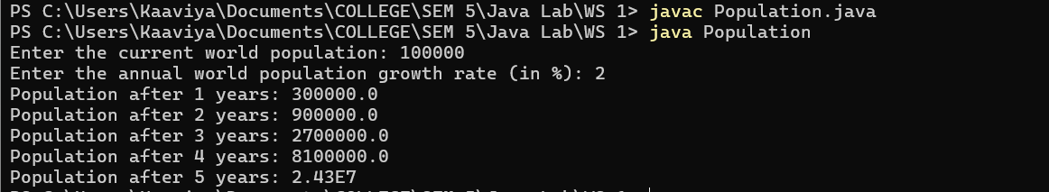

—----------------------------------------------------------------------------------------------------------------------------

15) Write a program that calculates your daily driving cost, so that you can estimate how much
money could be saved by car pooling, which also has other advantages such as reducing carbon emissions and reducing traffic congestion. The application should input the following
information and display the user’s cost per day of driving to work:
a) Total miles driven per day.
b) Cost per gallon of gasoline.
c) Average miles per gallon.
d) Parking fees per day.
e) Tolls per day.

import java.util.Scanner;
import java.lang.Math;

public class DailyDrivingCost {
public static void main(String args[]) {

Scanner obj = new Scanner(System.in);

System.out.print("Enter the Total miles driven per day: ");
float tot_miles = obj.nextFloat();
System.out.print("Enter the Cost per gallon of gasoline: ");
float cost_per_gas = obj.nextFloat();
System.out.print("Enter the Average miles per gallon: ");
float avg_miles_per_gas = obj.nextFloat();
System.out.print("Enter the Parking fees per day: ");
float parking_fee = obj.nextFloat();
System.out.print("Enter the Tolls per day(amt): ");
float tolls_cost = obj.nextFloat();

float tot_gas = tot_miles/avg_miles_per_gas;
float tot_gas_cost = tot_gas*cost_per_gas;

float driving_cost = tot_gas_cost + parking_fee + tolls_cost;
System.out.println("Daily Driving cost: " + driving_cost);
}
}

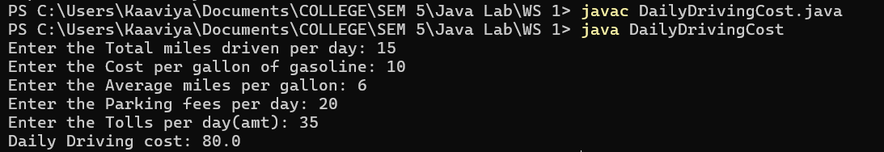

—----------------------------------------------------------------------------------------------------------------------------

16) Suppose you save $100 each month into a savings account with the annual interest rate 5%. Thus, the monthly interest rate is After the first month, the value in the account becomes
100 * (1 + 0.00417) = 100.417
After the second month, the value in the account becomes
(100 + 100.417) * (1 + 0.00417) = 201.252
After the third month, the value in the account becomes
(100 + 201.252) * (1 + 0.00417) = 302.507 and so on.
Write a program that prompts the user to enter a monthly saving amount and displays
the account value after the sixth month.

import java.util.Scanner;
import java.lang.Math;

public class AccountValue {
public static void main(String args[]) {

Scanner obj = new Scanner(System.in);

System.out.print("Enter the monthly savings: $");
float amt = obj.nextInt();

double acc_val = 0;

for(int i=0; i<6; i++){
acc_val = (amt + acc_val)*(1+0.00417);
}

System.out.println("The account value after the sixth month: " + acc_val);

}
}

—----------------------------------------------------------------------------------------------------------------------------

17) Body Mass Index (BMI) is a measure of health on weight. It can be calculated by taking your
weight in kilograms and dividing by the square of your height in meters. Write a program that
prompts the user to enter a weight in pounds and height in inches and displays the BMI. Note
that one pound is 0.45359237 kilograms and one inch is 0.0254 meters.

import java.util.Scanner;
import java.lang.Math;

public class BMI {
public static void main (String args[]) {

Scanner obj = new Scanner(System.in);

System.out.print("Enter the weight(in pounds): ");
double w = obj.nextDouble();

System.out.print("Enter the height(in inches): ");
double h = obj.nextDouble();

h = h*0.0254;
w = w*0.45359237;
double bmi = w/(h*h);

System.out.println("BMI: " + bmi);

}
}

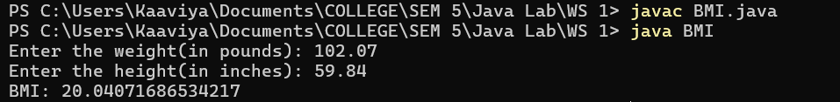

—----------------------------------------------------------------------------------------------------------------------------

18) How cold is it outside? The temperature alone is not enough to provide the answer. Other
factors including wind speed, relative humidity, and sunshine play important roles in
determining coldness outside. In 2001, the National Weather Service (NWS) implemented the
new wind-chill temperature to measure the coldness using temperature and wind speed.

import java.util.Scanner;
import java.lang.Math;

public class WindChillTemp {
public static void main(String args[]) {

Scanner obj = new Scanner(System.in);

System.out.print("Enter the outside temperature (in Fahrenheit): ");
float t = obj.nextFloat();
while(t < -58 || t > 41) {
System.out.println("Invalid Entry! Enter temperature between -58F and 41F.");
t = obj.nextFloat();
}

System.out.print("Enter the wind speed (in mph): ");
float v = obj.nextFloat();
while(v < 2) {
System.out.println("Invalid Entry! Enter wind speed above 2mph.");
v = obj.nextFloat();
}

double t_wc = 35.74 + (0.6215*t) - (35.75*Math.pow(v,0.16)) + (0.4275*t*Math.pow(v,0.16));

System.out.println("Wind-Chill Temperature: " + t_wc);

}
}

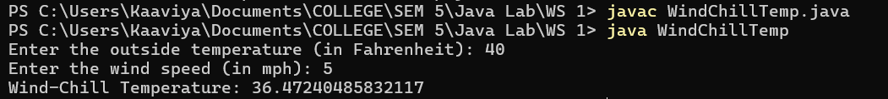

—----------------------------------------------------------------------------------------------------------------------------

19) Write a program that reads in investment amount, annual interest rate, and number of years,
and displays the future investment value

import java.util.Scanner;
import java.lang.Math;

public class Future_Investment_Rate {
public static void main(String args[]) {

Scanner obj = new Scanner(System.in);

System.out.print("Enter the investment amount: ");
int amt = obj.nextInt();
System.out.print("Enter the annual interest rate (in %): ");
float ar = obj.nextFloat();
float r = (ar/100)/12;
System.out.print("Enter the no. of years: ");
float yr = obj.nextFloat();

double future_invest_value = amt * Math.pow((1+r),yr*12);

System.out.println("Future Investment value: " + future_invest_value);
}
}

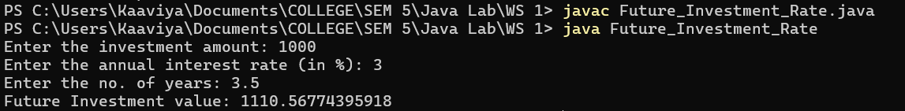

—----------------------------------------------------------------------------------------------------------------------------

20) Write an application that inputs one number consisting of five digits from the user, separates the number into its individual digits and prints the digits separated from one another by three
spaces each.

import java.util.Scanner;
import java.lang.Math;

public class NumberSplitting {
public static void main(String args[]) {

Scanner obj = new Scanner(System.in);

System.out.print("Enter a 5 digit number: ");
int num = obj.nextInt();

int div = 10000;
System.out.println("After splitting: ");

for(int i=0;i<5;i++) {
int n = num/div;
System.out.print(n + " ");
num = num%div;
div = div/10;
}
System.out.println("");
}
}





